

EU DECLARATION OF CONFORMITY
Nr.INT213i
We, INTERVISION TRADING RO SRL, default importer (manufacturer), with registered office in Mosoaia Commune, Smeura Village, 8 Fagetului Alley, declare under sole responsibility that the following products:
Brand name: AKAI
Type: ABTS-S2
Descriptions: PORTABLE SPEAKER
Lot: S202010XXXX
to which this declaration related is in conformity with the essential requirements of the following directives of the Council of the European Communities:
EUROPEAN COMMUNITY DIRECTIVE 2014/30/EU
EUROPEAN COMMUNITY DIRECTIVE 2014/35/EU
EUROPEAN COMMUNITY DIRECTIVE 2014/53/EU
EUROPEAN COMMUNITY DIRECTIVE 2011/65/EU (2015/863)

The products are compliant with the following standards:
EN 61000-4-2:2009
EN 61000-4-3:2006+A1:2008+A2:2010
EN 55032
EN 60950-1:2006+A11:2009+A1:2010+A12:2011+A2:2013
EN 62479:2010; EN 62321:2012
EN 301 489-1 V2.2.0 (2017-3)
EN 301 489-17 V3.2.0 (2017-3)
EN 300 328 V2.1.1 (2016-11)

and safety regulations:
EN 60065:2014
Certificate of conformity issued based on the Certificates HUAK180508152R/-1RR; HUAK180508276E; HUAK180508276-SR/-1ER/-2ER/-2EH of Shenzhen HUAK Testing Technology Co., Ltd, 1F, B2 Building, Junfeng Zhoncheng Zhiao Innovation Park, Helping Community, Fuhai Street, Bao’an District, Shenzhen, China.
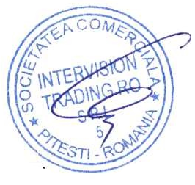
Intervision Trading Ro SRL,

Signature: __________________________

Printed name and Position:
CIOBANU DORIN – GENERAL MANAGER
Date: 14 Octomber, 2020
Place: Pitesti, Romania

